TYY BREAKFAST CLUB: FREQUENTLY ASKED QUESTIONS

Further to the details that were sent out in our Easter newsletter, please find below a series of frequently asked questions relating to the expansion of our breakfast provision at TYY for the 2025-26 school year.

What is the reasoning behind the change in provision?
The reasons are three-fold:
- The provision we have in place now is currently too long as a service that is only to provide food and, as such, children are having to be provided with wraparound care which the provision was never intended for;
- Some parents have asked for a longer provision, to enable them to drop children to school earlier than is currently possible under the existing breakfast club arrangements; and
- Some parents have asked for a provision that enables them to drop children to school later than is currently possible under the existing breakfast club arrangements.
The new offer will provide more options for families, whilst also maximising the staffing capacities we have available to us on our current budget.
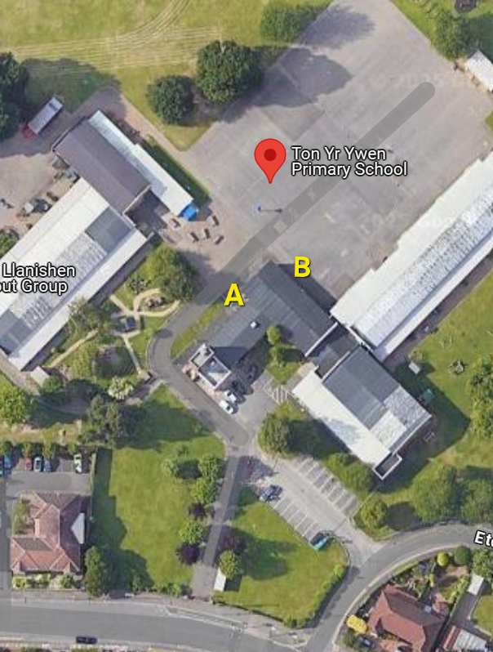

What are the timings for dropping children off?
From September 2025, parents using the paid wraparound provision will be able to drop children off between 8am and 8.25am, to the door marked ‘B’ on the map shown here (at the rear of the canteen). Parents using the free breakfast club will be able to drop children off between 8.30am and 8.40am, to the door that is currently used for breakfast club drop offs (marked ‘A’ on the map shown here).

What time will food be served?
Breakfast will be available from 8.30am, which will provide children with sufficient time to choose their breakfast and eat it without rushing before starting the school day (in line with Welsh Government Guidance). Prior to 8.30am, those children attending the wraparound care provision will be able to take part in a range of activities between the time that they are dropped at school and 8.30am when food will be served. Those activities will be table-top activities, determined by pupil voice. As part of the provision, the children will help to tidy away these resources in readiness for breakfast being served at 8.30am.
How much will the new wraparound care provision cost?
It will be £3 per child, and £2.70 per subsequent sibling, for children to attend the wraparound care provision that will run between 8am and 8.25am. The breakfast club provision that will run from 8.30am will be free.

Can I use childcare vouchers to pay for the wraparound care provision?
Sadly, we are not able to take childcare vouchers as payment, as the school is not classed as a provider who can accept those vouchers.

How can I book my child(ren) in to the new wraparound provision and/or the free breakfast club provision, for the 2025-26 school year?
You will need to complete a booking form to book in to either provision. You can download that form by going to Ton-Yr-Ywen Primary School - Breakfast Club and you can then email the completed form to us at tonyrywenprm@cardiff.gov.uk. Alternatively, you can ask at the school office for a paper copy of the form, and the completed form can then be returned to staff in the school office. Please ensure that a form is completed for every child that you wish to attend either provision, even if they already attend the free breakfast club that is currently in place.

When do I need to book in by if I want my child(ren) to use the new wraparound provision and/or the free breakfast club provision from September 2025?
You will need to complete and return the booking form mentioned above by Monday 7th July.

What if I didn’t express an interest when the questionnaire was sent out previously?
Don’t worry, it doesn’t matter! Anyone wishing to book on to either provision can do so by completing a booking form, as detailed above.

How will I be able to make payment for the wraparound care provision?
Payment will need to be made via ParentPay, and you will be required to pay for half a term at a time. This can be paid as a block payment or via instalments. If payment is not received, reminders will be sent and the school will have the option to remove access to the wraparound care provision in the case of non-persistent payment.

Can we vary the days that we use the paid wraparound provision?
You will need to book for at least a term in advance, and at that time you will be required to choose the days that you need to use the paid wraparound provision during the term that you are booking for. If you need to change days, you can do so when booking for the start of the next term.

Can you book in on an ad-hoc basis?
No, apart from in exceptional circumstances that would need to be approved by the headteacher. This is due to staffing, which needs to be in place in advance of each term.

Are there any restrictions on the number of children that can attend breakfast club?
No, at present we anticipate no restrictions: however, as with the provision overall, it will remain under review and updates will be shared in advance of any necessary changes.

